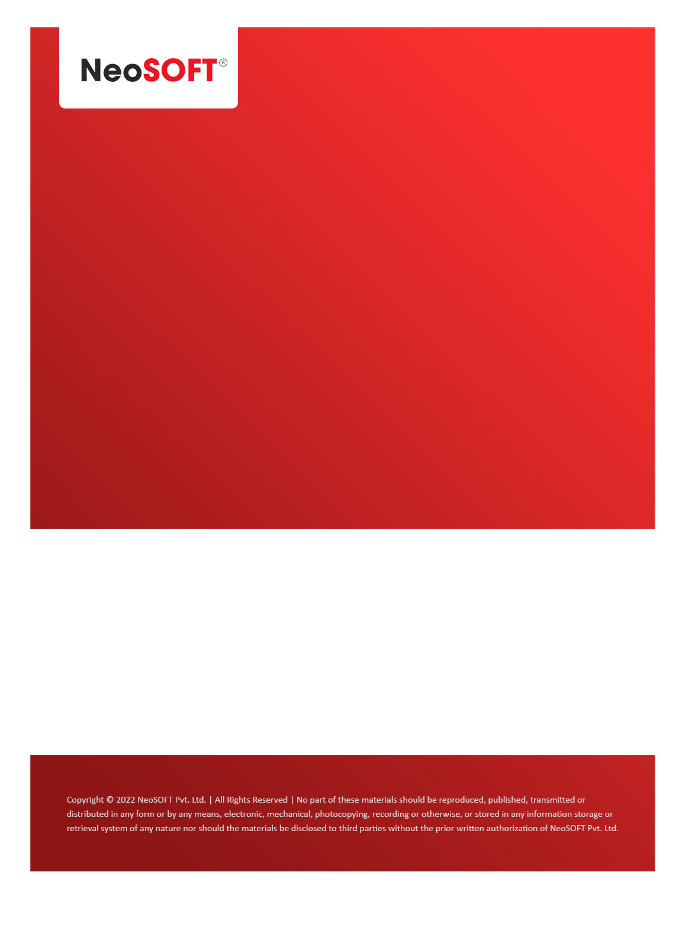`

**Eltizam MOM – Design review, Updates**

Eltizam

Client Name

NeoSOFT is a SEI-CMMI Level-5 Global IT Consulting & Software Solutions Provider

**3rd Aug,** 2023

|  |  |
| --- | --- |
| **Meeting Date, Time, and Attendee Details** | |
| **Date** | 3rd Aug 2023 |
| **Venue** | MS Teams |
| **Time** | 11.00 AM – 11.45 AM IST |
| **Meeting Type** | Project status discussions – Design phase |
| **Internal Attendees** | * YallaReddy |
| **Client Attendees** | * Karuna Pawar |
| **MOM Prepared By** | * YallaReddy |

|  |  |
| --- | --- |
| **Details of Meeting** | |
| **Sr. No.** | **Description** |
| 1 | Karuna shared screen and discussed design page review changes. |
| 2 | Below are the design feedback changes from meeting  --> List items should transparent sky blue with alt colour from Colliers logo  --> Font style should be Calibri  --> Add New button should in similar in all page & should be different colour  --> Popup should be big size  --> Close X should be X on popups  --> Full Name to First Name, Last Name (Need to get clarification for Full Name)  --> Menu should with sub task Ad New, List (expandable)  --> Search bar with half of the page & place all buttons in one section  --> Hyper link to View & then Edit on View page  --> Remove View/Edit on grid  --> Header should be in middle  --> Put buttons on button group  --> column should be ID (in list)  --> Add ... in grid for any action items & remove Edit, View buttons from page. |
| 3 | Discussed Approver master page design and took notes on changes to be implemented on the page. |
| 4 | Figma URL  <https://www.figma.com/file/XWYl9trSHWtPdOCUUsqbYj/EltizamWebAdminApp?type=design&node-id=100-26750&mode=design> |
| 5 | Figma Protocol URL <https://www.figma.com/proto/XWYl9trSHWtPdOCUUsqbYj/ColliersWebAdminApp?page-id=100%3A26750&type=design&node-id=188-3750&viewport=1427%2C-875%2C0.23&t=mQOsCXjQdl6SPxbw-1&scaling=scale-down-width&starting-point-node-id=188%3A3750&mode=design> |
| 6 | We are targeting to complete design & SRS documents for next week end. By that time, we can have open items answers from end client. |

|  |  |  |  |  |  |
| --- | --- | --- | --- | --- | --- |
| **Actionable** | | | | | |
| **Sr. No.** | **Action Item** | **Assigned to** | **Assigned Date** | **Expected Completion Date** | **Status** |
| 1 |  |  |  |  |  |
| 2 |  |  |  |  |  |
|  |  |  |  |  |  |